MPM735_MPM935
INTERNATIONAL BUSINESS MANAGEMENT

Group-50

Project submitted on: May 8, 2015
Word Count: 3983 Excluding References and table of contents.

Table of Contents:
S.NO | Title | Page No
1. | Executive Summary | 3
2. | Introduction | 3
3. | Economic Factors | 3 – 8
4. | Political Factors | 8
5. | Legal | 8 - 11
6. | FDI | 11 - 12
7. | Finance | 12 - 14
8. | Socio-Cultural | 14 – 15
9. | Forecast | 15 – 16
10. | Recommendations and Conclusion | 16

Executive Summary:
This report broadly entails the country profile of Chile in terms of the incumbent ambience experienced by the country keeping in view the essence of factors affecting its ambience most important of which is the incumbent government which has taken its hold this year. These factors encompassing economic, political, social, financial and legal have been discussed in detail to give a succinct picture to the board of directors of Neon Cosmetics as it aims at entering the Turkish market with its range of cosmetic products. The report also gives a brief conclusion and recommendation for Neon cosmetics.

Introduction
The organization neon cosmetic which is an Australian based organization needs to go into the business sector of turkey. The organization is a leading cosmetics organization which deals in assembling, item detailing, and logistics administration. Neon cosmetics is additionally the main contract producer of shading beauty care products in Australia, which gives advancements and quality items to Australia's driving brands and retailers. It spends a huge amount of money in development and innovative work for basically two reasons, "Future Beauty" and "Determining Programs "The company produces $19.6M in yearly income , which is 10 times higher than the normal for all toilet preparation organizations in Australia ($1.91M) - this puts the association in the main 20% of organizations in the business. The organisation employs 50 people (estimated).The capability of the Turkish cosmetics business sector is tricking new makeup and individual consideration brands into the business sector. In the most recent two years, more than 40 new brands have entered the developing Turkish beauty care products business, tending to all business sectors. The growth of the international brands in Turkish cosmetics market is expected to grow. An combination of measurements and data about the general feeling the nation flourishes in to see Turkey from a general point of view however basically from the viewpoint of an outside firm entering a well-constructed centre pay economy. The report was limited to measurable and hypothetical information from the penultimate decades.

Economic Factors of turkey:
1. Economic policy of the government:
In the earlier decade, turkey's money related system can be broken into three stages:
The essential stage came in 2001 which started with turkey's cash and dealing with a record crisis and kept going until the overall crisis of 2007 to 2008.But with the help of genuine change of the keeping cash part, credit began spilling eventually into the economy. The second stage started with the general fiscal shock of 2008, which at first sent Turkey's economy into a sharp reducing: It shrunk by pretty about 5 % that year. In any case, the recovery came quickly by accepting certain game plans. Technique encouraging and low interest environment at home and abroad thought to be customary change of 9 % through the going with two years.
Shortly the country has entered a third stage. Design improvement is directing clearly as the economy influences basically powerless before overall shocks, for instance, the euro zone crisis or the reductions in quantitative encouraging by the United States Federal Reserve. At that point open spending has enabled while private zone stays passionless, proposing that the private fragment drove progression that one turkey's organization got a kick out of the opportunity to gloat about its losing power. (BY MURAT UCER August 2014)

2. GDP Growth in turkey:
The Gross Domestic Product (GDP) in Turkey extended 0.70 % in the final quarter of 2014 over the past quarter. Gross domestic product in Turkey found the middle value of 0.93 per cent from 1998 until 2014, coming to a record-breaking high of 6.69 % in the second quarter of 2009 and a record low of -7.57 % in the first quarter of 2009. Gross domestic product Growth Rate in Turkey is accounted for by the Turkish Statistical Institute. 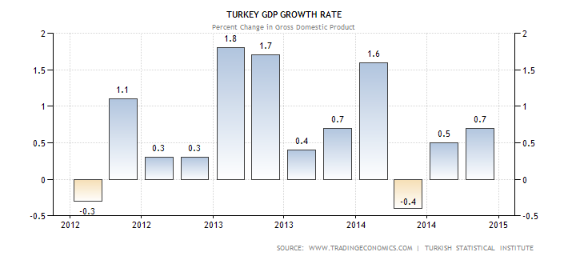

Per Capita income:
The Gross Domestic Product capita in Turkey was previously put down at USD 8716.68 in 2013. The Capita income in Turkey is proportional to 69 % of the world's normal. GDP capita in Turkey arrived at the midpoint at 4841.08 USD from 1960 until 2013, coming to an unequalled high of 8716.68 USD in 2013 and a record low of 2315.94 USD in 1961. GDP capita in Turkey is accounted for by the World Bank.
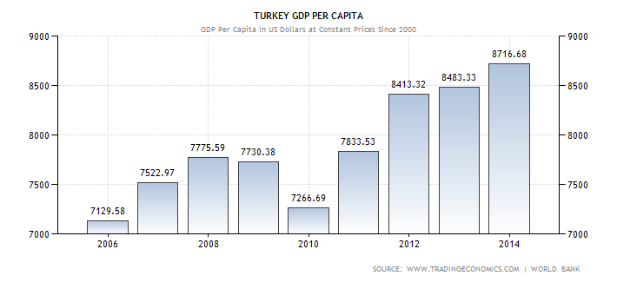

CPI Trend:
Purchaser Price Index (CPI) in Turkey expanded to 259.39 Index Points in April of 2015 from 255.23 Index Points in March of 2015. Purchaser Price Index CPI in Turkey arrived at the midpoint of 165.26 Index Points from 2003 until 2015, coming to a record-breaking high of 259.39 Index Points in April of 2015 and a record low of 94.77 Index Points in January 2013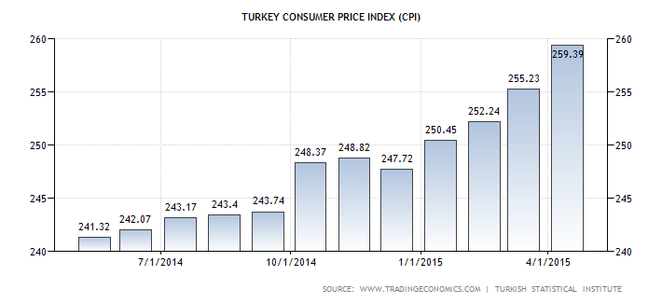

Inflation Trend: The chart below shows the overview of the Turkish inflation in 2014:
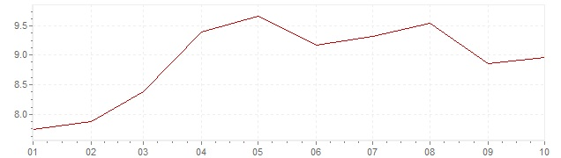
In 2014, turkey's average inflation was 8.85%
Turkish customer costs expanded 7.91 per cent year-on-year in April of 2015, after a 7.61 per cent ascend in the earlier month. It is the most astounding swelling rate in four months because of rising sustenance costs.
Unemployment Trend:
Turkey's unemployment rate rose to a 4-year high of 10.9% in Dec 2014, up from 10.7 % in Nov 2014 and 10 % in Dec 2013, as showed by the Labour Force Statistics information discharged by the Turkish Statistics Institute (TÜİK) on March 1.( ISTANBUL - Doğan News Agency).
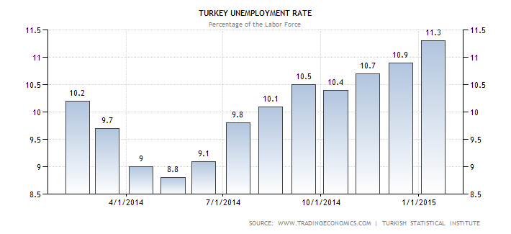
Infrastructure:
Turkey is in an uncommon geographical position partner of both Europe and Asia. It is additionally one of the key nations in the Middle East district for base attempts. As showed by Goldman Sachs, Turkey will transform into the world's ninth greatest economy by 2050.( Hurriyet Daily News).The change piece has developed quickly beginning late, profiting from circumstances in the region economy moreover effect https:
• Turkey tries to accomplish vigorous focuses in its foundation segment by 2023. A piece of the genuine targets are as indicated by the going hand in hand with;
Expanding the length of lively rail course lines to 10,000 km from 888 km with a 25% CAGR.
• Climbing to around 7400 km of Roadways from 2,235 km in 2013
•Expanding its voyager uttermost scopes of air terminals from 166mtructure:

Tariff:
Exacts on imports from non-European countries Demands on imports from non-European nations is nearly 3 every penny above (EU) rates, yet change on a thing by-thing reason. VAT pertains in Turkey paying little regard to the nation of starting stage. For most developing things (focal bolster) VAT ranges from one to eight every penny and for some took care of things can reach up to 18 each penny. In spite of the EU association, Turkey keeps on keeping up various evaluation and non-force obstacles to control and breaking point imports, especially for cultivating things (numbering wine).

Current Account:
Turkey's present account deficit halved in January from a year prior because of diving oil costs and powerless imports, sending the lira higher against the dollar. The present record shortage, which measures Turkey' short outside financing needs, dropped by 60% to $2.002 billion in January from $4.98 billion in the same time of 2014. Turkey's 12-month current-account deficiency tumbled to $42.9 billion, or 5.2% of GDP, from $45.8 billion last year. (YELIZ CANDEMIR March 2015)
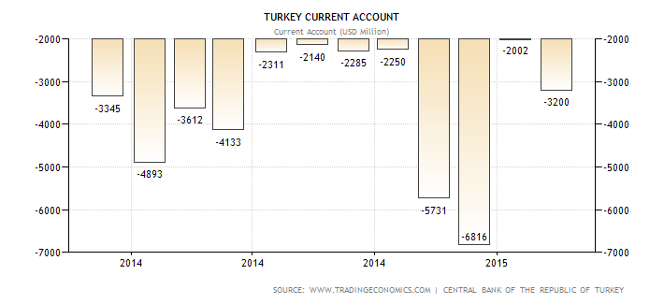

Trading partners and key imports and exports:
The bubble graph tracks Turkey's exchange volume with every accomplice by import (y-axis) and export (x-axis). Every exchanging accomplice is spoken to by a different "air pocket," the span of which shows
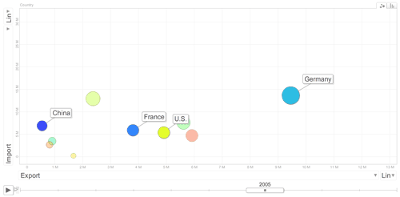

Trade Agreements:
Exchange Policy:
Better market access opportunity
Crude material supply procedure providing organizations the same rivalry conditions with the EU
Disposal of duties and standards on generously all the exchange
Free development of merchandise, in light of standards of inventiveness
Political and Legal:
Government type in turkey is Parliamentary democracy with free market economy.
Government structure:
Constitution:
First constitution adopted by Turkey in 1994. It held the fundamental standards of the 1921 Constitution, remarkably the guideline of national sway. The 2nd Constitution of the Republic of Turkey was grasped in 1961. National Assembly contains 450 delegates and the Senate of the Republic contains 150 people picked by general ballot and 15 people picked by the President. The third Constitution of the Republic of Turkey was gone in 1982 by a national submission is still as a result today. All people are level with no separation under the watchful eye of the law, independent of dialect, race, shading, sexual orientation, political introduction, philosophical belief, religion and faction, or any such contemplation. The 1982 Constitution expresses all essential human rights and flexibility like, discourse, press, home, development, religion, inner voice, contemplation and conclusion, outflow, correspondence, right to security, property, gatherings and insurance of legal judgment.
Legislative:
Legislative power is vested in the (TGNA) Turkish Grand National Assembly for the Turkish nation and this power can't be appointed. TGNA created out of 550 delegates, while Parliamentary decisions are held at normal interims. Deputies identify with the entire nation and before expecting office, take an oath. TNGA comprise the reception of draft laws, change and nullification of current law, supervision of cabinet and minister, debating, approval of budget draft, draft laws for final account, printing currency related decision, declaration of war, emergency rules, international agreements and exonerates in accordance with the Constitution.
Judicial Section:
Judicial area of the constitution includes the Constitutional Court, Supreme Military Court of Appeal, and Supreme Court Of appeal, Council of State, Court Of Jurisdictional Conflicts and Supreme Military Administrative Court.
President elected by the National Assembly for 7 years of term. President takes care of entire state department and entire procedures of the constitution. His duties are publishing and returning laws to the parliament for revision decide the renewal of elections and appoint the prime minister.
Prime minister gets elected by public for 5 years term. Minister can be expelled from their obligations by the president upon the proposition of the Prime Minister when considered fundamental. Obligations of Council minister are to form and execute the interior and foreign approaches of the state.
International relations with other countries:
Turkey has very good relations with US (United States) and the European nations; while in future building up its great relationship with the some nations, that is Balkans, Middle East and North Africa, Southern Caucasus, South Asia and Central Asia by making utilization of its near to ties. Turkey does not just build up its two-sided and provincial relations in its nearby neighbourhood, yet looks to make a positive cooperative energy on a much more extensive scale and therefore goes for adding to worldwide peace, soundness and security. Turkey seeks after a dynamic and visionary outside arrangement with a perspective to guiding the improvements in positive bearing, in an area where the effects of worldwide changes are most prominent.
Corruption Perception Index (CPI) showed that Turkey moved from the 53rd least corrupt country to the 64th.

Political Risk Associated with the country:
The through and through triumph of Recep Tayyip Erdogan in Sunday's vote, the 1st round of Turkey's first prevalent presidential race, did minor to improve the political danger to Turkey's sovereign credit profile, Fitch Ratings says. The outcome avoids a second count and certifies Erdogan's own particular staying with a colossal bit of the electorate. In any case, political danger will weigh on Turkey's evaluations through its potential impacts to debilitate capital inflows and diminishing plan consistency.
Rules and regulations for foreign business:
Turkey's is very much business-friendly. Anyone can conduct business activities in Turkey independent of any nationality, or spot of home. The organization gets its "lawful substance" status upon enlistment with the exchange registry.
Foreign speculators are allowed to make FDI (foreign Direct Investment) in Turkey, Foreign financial specialists might be liable to equivalent treatment with residential financial specialists, Foreign direct ventures should not be confiscated or nationalized, with the exception of an open reason and upon remuneration as per due procedure of law. Foreign speculators can unreservedly exchange benefits, profits, continues from the deal or liquidation of all or any piece of a venture, sums emerging from permit, administration and comparative understandings, and repayments and premium instalments emerging from remote credits through banks or uncommon monetary foundations to abroad.
For the settlement of debate emerging from venture assertions subject to private law and question emerging from conditions and contracts, outside financial specialists can apply either to the approved neighbourhood courts, or to national or worldwide mediation.
Non-money capital is esteemed inside the regulations of Turkish Commercial Law. Then again, stocks and obligations of organizations living abroad will be acknowledged as remote capital offer of outside speculators.
Persons with outside nationality can purchase greatest 30 hectares of land or property in Turkey altogether and can get restricted in rem right.
Labour and employment law:
Employment contracts are not subject to charge any stamp tax or any other kind of fees or duties.
As per the Labour Law, Total hours of workings are 45 per week. As per the principle all this hours should equally distributed among working days in the organisation.
Employees are entitled to get vacation for below Period as an annual Vacation:
1 - 5 years of Period = 14 working days, 5 - 15 years of Period = 20 working days, 15 years or more years of Period = 26 working days.
According to the Labour Law, in the event that the business initiates no less than 10 labourers inside the same work environment or over the entire nation; any premium, wage, pay, and so forth to be paid to specialists should be paid in Turkish currency that is Lira (TRY) to the bank accounts of representatives.

FDI (Foreign Direct Investment):
Foreign direct investment inflow is 12.5 USD billion in turkey for 2014.
FDI (Foreign Direct Investment) Inflow and Outflow to Turkey by Year (USD Million):
 | 2014
FDI Total (Net) | 12,530
Equity Investments (Net) | 8,445
Inflows | 8,699
Liquidation Outflows | 254
Intra -Company Loans* | -236
Real Estate (Net) | 4,321

From where FDI Inflow came into Turkey:
The major part of FDI inflows came from North America, Europe and the Gulf countries.
 | 2014
Europe | 6,566
Developed Europe | 5,512
EFTA countries | 324
Other European countries | 730
Africa | 42
North Africa | 0
Other African countries | 42
America | 325
North America | 325
Central America | 0
South America | 0
Asia | 1,766
Near and Middle Eastern countries | 1,231
Arabian Gulf countries | 425
Other Near and Middle Eastern countries | 788
Other Asian countries | 535
Oceania and polar regions | 0
Unclassified | 0
 | 8,699

Special economic zone:
Organized Industrial Zones:
Organized Industrial Zones (OIZs*) permits organizations or businesses to work into a speculator cordial environment with prepared to use framework and social offices. The current foundation gave in the zones incorporates streets, water, regular gas, power, interchanges, waste treatment, and different administrations.
Advantages:
- For land acquisitions no VAT.
- Exemption from land obligation for a long time beginning later development of the plant.
- Less charges for gas, telecommunication costs, and water.
- No tax to be paid for unification and/or detachment of land or plots. No municipality tax as well as no construction charges and usage charges of the plant.
- No district charge on the strong waste if the OIZ does not advantage from the region administration.

Free zones:
Free zones are uncommon destinations thought to be outside the traditions zone, despite the fact that they are inside the political outskirts of the nation. These zones are intended to expand the quantity of fare centred speculations. Lawful and regulatory regulations in the business, money related, and monetary fields that are material inside the traditions region are either not actualized or part of the way executed in the free zones.
Advantages:
- 100% exemption - Assorted duties and customs duties, from corporate salary charge for assembling organizations, from VAT and unique utilization charge, from wage impose on workers' compensations. Goods can be into this zone for an infinite period.
- Organisations are no limits transfer earnings from these sectors to foreign as well as into Turkey, without any kind of restrictions.

Finance:
Types of Banks –
Commercial Banks, Banks Under the Deposit Insurance Fund, Foreign Banks, Privately Owned Commercial Banks, Sate Owned Commercial Banks, Non – Depository Banks, Foreign Non – Depository Banks, Privately Owned Non – Depository Bank, State Owned Non – Depository Banks.
Banking System-
The banking division frames an extraordinary piece of the Turkish budgetary framework in its dynamic economy. The vast majority of the exchanges and exercises of cash and capital markets are done by banks. Most State banks were made to fund a specific industry, for example, farming for instance (Ziraat Bank), however private banks by and large have close associations with huge mechanical gatherings and possessions.
All banks have to follow Banks Act in Turkey and to the procurements of different laws with respect to banks. Banking Regulation and Supervision Agency brought out a new law which gives a life to defend the rights and advantages of contributors. The Banks Association of Turkey is the agent group of the keeping money segment in Turkey created for securing and advancing the expert premiums of its individuals.

Access to Finance and Interest Rates:
During fiscal year 2014, International Financial Corporation committed a record $1.24 billion in investments in 23 projects, up from $985 million the previous year, including mobilizations and syndications.
The Bank keeps the Landing cash rate at 7.25%, 10.75% the negligible subsidizing rate, and the premium rate on getting workplaces suited crucial vendors at 10.25%. Bank announced to diminish the Foreign Exchange store attributing rates 4.0% from 4.5%. That is for USD, and for EUR 2.0% from 2.5%.
Normal Bank rates are 9.20% - to 9.25%. Interest rates on deposits vary from 8.75% - 9.50%. Interest rates on loan are 15.36% - 16.08%. Credit interest rates are 24.24% - 27.12%.
Turkish Lira is a Currency in Turkey. Currency symbol is .
At present 1 Turkish Lira is equivalent to 0.36871 US dollars.
Taxation Rules:

No impediment for repatriation of points of interest unless the affiliation is checked by an upper supervisory body whose admiration is needed. In the wake of corporate assessment which is calculated at 20%, it can be 15% advantage withholding commitment if the point of interest is appropriated to neighbouring ordinary persons or outside fundamental/legitimate persons. As per the Turkish charge framework, every last assessable substance is at danger to equal regale withholding expense rate, which is 15% and is connected with focal points after evaluation. Because of Turkey's Double Taxation Treaties, Positive advantage withholding expense rates is still in existence. More than 70 Double Taxation Treaties checked are there in Turkey with different nations. If vapid 15% rate is greater than DTT advantage withholding assessment rate then its more suitable and, the DTT rate may apply. Remote fiscal specialists are allowed to exchange advantages to abroad as indicated by the Foreign Direct Investment Law. In any case, the Turkish Commercial Code genuine store necessities should in like way is met. There are no obstructions concerning advantage divides under the Foreign Exchange foundation; however the advantage withholding expense must be paid by everyone before the repatriation. This will specially get checked by the banks utilized for the exchange.

Income tax rate Structure is given below:

Income in Turkish Currency (Employment Income) | Rate of Tax | Income in Turkish Currency  (Non-Employment Income) | Rate of Tax
Less Than 12,000 | 15% | Less Than 12,000 | 15%
Between 12,001 to 29,000 | 20% | Between 12,001 to 29,000 | 20%
Between 29,001 to 106,000 | 27% | Between 29,001 to 66,000 | 27%
106,001 and above | 35% | 66,001 and above | 35%

Socio-Cultural:
99.8% of Muslims (Sunni Caste) in the Turkey and other are 0.2%. Religion is Islam for the predominant bit of Turks ignoring the way that the state is irately essential. Islam overflowed from Saudi Arabia. The Prophet Muhammad is God's emissaries to go on revelation to humanity. Muhammad brings the Quran. The Quran and the activities of the Prophet are utilized as the explanation behind all heading in the religion.
At the point when meeting shake hands solidly. At the point when withdrawing it is not generally standard to shake hands in spite of the fact that it is rehearsed periodically.
Companions and relations would welcome one another with either maybe a couple kisses on the face. Older folks are constantly regarded by kissing their right hand then setting the brow onto the hand.
Welcome individuals with word ‘Asalamu alaykum'.
Turks want to work with those they know and appreciation, in this manner invests energy securing an individual relationship.
Associations are empowered in the working environment, over expanded snacks, dinners, and social trips. Civility is vital in all business dealings.
Turks don't require as much individual space the same number of different societies and will stand near to you while talking.
Step back can be translated as antagonistic.
Talks may start slowly, with various requests that may have all the earmarks of being insignificant to the explanation behind your visit. It is to an extraordinary degree rude to request that your partners go to the heart of the matter.
The Turks are upbeat for their nation and will recognize perceiving demand on their way of life and history in spite of the way that make a point to stay a long way from political history.
Holidays List:
New Year, Day of Mourning for King Abdullah, March equinox, National Sovereignty and Children's Day, Labour and Solidarity Day, Commemoration of Atatürk, Youth and Sports Day, June Solstice, Ramadan Feast Eve and 3 Days, Victory Day, September equinox, Sacrifice Feast Eve and 4 Days, Republic Day, December Solstice, New Year's Eve.
Hofstede’s Dimension on the country in comparison to Australia:
This measurement manages the way that all people in social orders are not equivalent – it communicates the demeanour of the way of life towards these imbalances amongst us. Force separation is characterized as the degree to which the less capable individuals from establishments and associations inside a nation expect and acknowledge that power is appropriated unequal.
Correspondence is aberrant and the agreement of the gathering must be kept up, open clashes are maintained a strategic distance from. The relationship has an ethical base and this dependably has need over undertaking satisfaction. Time must be contributed at first to create a relationship of trust. Nepotism may be discovered all the more frequently. Criticism is constantly aberrant, additionally in the business environment.
Overwhelming values in the public eye are watching over others and personal satisfaction. A female society is one where personal satisfaction is the indication of achievement and emerging from the group is not excellent.
To minimize nervousness, individuals make utilization of a ton of ceremonies. For outsiders they may appear to be religious, with the numerous references to "Allah", yet regularly they are simply customary social examples, utilized as a part of particular circumstances to facilitate pressure.

Forecast:
In addition, Turkey's great financial execution over the previous decade has empowered specialists and worldwide foundations to make certain projections about Turkey's monetary future. Turkey is relied upon to be one of the quickest developing economies of the OECD individuals amid
2014-2016, with a yearly normal development rate of 3.6 percent. 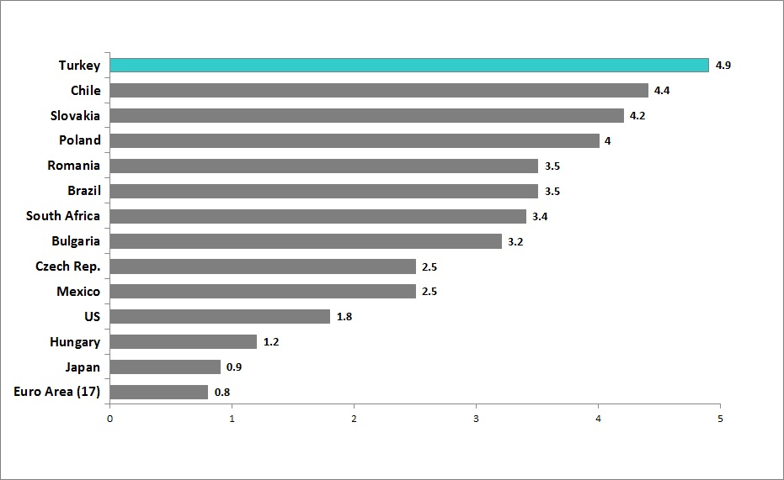
In the impending four to five years it is exceptionally likely that the Turkish business will develop to be more shoppers amicable and Neon Cosmetics stands to pick up from this development in spite of the intense rivalry forced by the neighbourhood and existing firms.

Conclusion/Recommendation
The report is finished up with a firm stance for Neon Cosmetics entering the Chilean showcase, however it must be watchful in adjusting to different conventions and harvest the advantages Turkish economy gives towards little and medium ventures. Additionally Neon Cosmetics ought to plan to acquaint items spreading over all reaches with tap all the wage bunches. The officeholder makeup industry contradicts an intense rivalry yet in the event that Neon Cosmetics plays its cards right with inventive items and special procedure coupled with far reaching advertising, it stands to support as well as make extensive benefits from the occupant and advanced vibe in turkey.

References:
2015. [ONLINE] Available at: http://www.unipro.org/home/it/aree_professionali/centro_studi/schede_paese/Continente/Europa/Turchia/2008/documenti/THE_COSMETICS_SECTOR_IN_TURKEY_-_ICE.pdf. [Accessed 08 May 2015].
Turkey’s Economy: Now for the Hard Part | Foreign Policy. 2015. Turkey’s Economy: Now for the Hard Part | Foreign Policy. [ONLINE] Available at: http://foreignpolicy.com/2014/08/12/turkeys-economy-now-for-the-hard-part/. [Accessed 08 May 2015].
Turkey GDP Growth Rate | 1998-2015 | Data | Chart | Calendar | Forecast . 2015. Turkey GDP Growth Rate | 1998-2015 | Data | Chart | Calendar | Forecast . [ONLINE] Available at: http://www.tradingeconomics.com/turkey/gdp-growth. [Accessed 08 May 2015].
Inflation Turkey 2014 – CPI inflation Turkey 2014. 2015. Inflation Turkey 2014 – CPI inflation Turkey 2014. [ONLINE] Available at: http://www.inflation.eu/inflation-rates/turkey/historic-inflation/cpi-inflation-turkey-2014.aspx. [Accessed 08 May 2015].
( ISTANBUL - Doğan News Agency).http://www.hurriyetdailynews.com/turkeys-unemployment-rate-increases-to-4-year-high-.aspx?pageID=238&nID=79738&NewsCatID=347//www.austrade.gov.au/Export/Export-Markets/Countries/Turkey/Industries#.VUrv_txd9Xoively entering the Middle East, Central Asia and Russian market.
Turkey’s Current Account Deficit More Than Halves in January - WSJ . 2015. Turkey’s Current Account Deficit More Than Halves in January - WSJ . [ONLINE] Available at: http://www.wsj.com/articles/turkeys-current-account-deficit-halves-in-january-1426092711. [Accessed 08 May 2015].
Doing business - Tariffs and regulations – Turkey – For Australian exporters - Austrade . 2015. Doing business - Tariffs and regulations – Turkey – For Australian exporters - Austrade . [ONLINE] Available at: https://www.austrade.gov.au/Export/Export-Markets/Countries/Turkey/Doing-business/Tariffs-and-regulations#.VUr1htxd9Xo. [Accessed 08 May 2015].
Programs | Center for Strategic and International Studies. 2015. Programs | Center for Strategic and International Studies. [ONLINE] Available at: http://csis.org/programs/kissinger-chair/us-turkey-strategic-initiative/turkey. [Accessed 08 May 2015].
Economic Outlook - Invest in Turkey . 2015. Economic Outlook - Invest in Turkey . [ONLINE] Available at: http://www.invest.gov.tr/en-us/turkey/factsandfigures/pages/economy.aspx. [Accessed 08 May 2015].
Legal and Political Structure - Invest in Turkey. 2015. [ONLINE] Available at: http://www.invest.gov.tr/en-US/turkey/factsandfigures/Pages/LegalAndPoliticalStructure.aspx. [Accessed 08 May 2015].
Establishing a Business in Turkey - Invest in Turkey. 2015. [ONLINE] Available at: http://www.invest.gov.tr/en-US/investmentguide/investorsguide/Pages/EstablishingABusinessInTR.aspx. [Accessed 08 May 2015].
Turkey - Geert Hofstede. 2015. Turkey - Geert Hofstede. [ONLINE] Available at: http://geert-hofstede.com/turkey.html. [Accessed 08 May 2015].
Foreign Direct Investment Law - All About Turkey. 2015. [ONLINE] Available at: http://www.allaboutturkey.com/investment.htm. [Accessed 08 May 2015].
Terms of Employment - Invest in Turkey. 2015. [ONLINE] Available at: http://www.invest.gov.tr/en-US/investmentguide/investorsguide/employeesandsocialsecurity/Pages/TermsOfEmployment.aspx. [Accessed 08 May 2015].
FDI in Turkey - Invest in Turkey. 2015. [ONLINE] Available at: http://www.invest.gov.tr/en-US/investmentguide/investorsguide/Pages/FDIinTurkey.aspx. [Accessed 08 May 2015].
Special Investment Zones - Invest in Turkey. 2015. [ONLINE] Available at: http://www.invest.gov.tr/en-US/investmentguide/investorsguide/Pages/SpecialInvestmentZones.aspx. [Accessed 08 May 2015].
Banking system - All about Turkey. 2015. [ONLINE] Available at: http://www.allaboutturkey.com/banks.htm. [Accessed 08 May 2015].
IFC Strategy in Turkey. 2015. [ONLINE] Available at: http://www.ifc.org/wps/wcm/connect/region__ext_content/regions/europe+middle+east+and+north+africa/ifc+in+europe+and+central+asia/countries/turkey+country+landing+page. [Accessed 08 May 2015].
Turkey Interest Rate - News, Data, Forecasts and Charts. 2015. [ONLINE] Available at: https://www.focus-economics.com/country-indicator/turkey/interest-rate. [Accessed 08 May 2015].
Turkey Bank Account Rates - Compare Turkish Bank Interest Rates. 2015. Turkey Bank Account Rates - Compare Turkish Bank Interest Rates. [ONLINE] Available at: http://turkey.deposits.org/. [Accessed 08 May 2015].
Turkish Lira Exchange Rate Today With Live Turkish Lira Currency Converter - TRY at Exchange Rates UK. 2015. Turkish Lira Exchange Rate Today With Live Turkish Lira Currency Converter - TRY at Exchange Rates UK. [ONLINE] Available at: http://www.exchangerates.org.uk/Turkish-Lira-TRY-currency-table.html. [Accessed 08 May 2015].
Transfer of dividends outside Turkey - Inlawco law offices, international lawyers and counsels in istanbul, acting all over Turkey. 2015. Transfer of dividends outside Turkey - Inlawco law offices, international lawyers and counsels in istanbul, acting all over Turkey. [ONLINE] Available at: http://www.inlawco.com/en/transfer-of-dividends-outside-turkey. [Accessed 08 May 2015].
Holidays and observances in Turkey in 2015. 2015. Holidays and observances in Turkey in 2015. [ONLINE] Available at: http://www.timeanddate.com/holidays/turkey/. [Accessed 08 May 2015].

